Equatorial Guinea

## GNI per capita and development level

The data set shows the GNI per capita and development level of the country each year.

## # A tibble: 19 x 5  
## country iso3c date GNIperCapita devCategory   
## <chr> <chr> <dbl> <dbl> <chr>   
## 1 Equatorial Guinea GNQ 1996 30203. High Income   
## 2 Equatorial Guinea GNQ 1998 30571. High Income   
## 3 Equatorial Guinea GNQ 2000 2988. Lower Middle Income  
## 4 Equatorial Guinea GNQ 2002 2988. Lower Middle Income  
## 5 Equatorial Guinea GNQ 2003 4804. Upper Middle Income  
## 6 Equatorial Guinea GNQ 2004 4804. Upper Middle Income  
## 7 Equatorial Guinea GNQ 2005 9895. Upper Middle Income  
## 8 Equatorial Guinea GNQ 2006 12543. High Income   
## 9 Equatorial Guinea GNQ 2007 14089. High Income   
## 10 Equatorial Guinea GNQ 2008 13777. High Income   
## 11 Equatorial Guinea GNQ 2009 13835. High Income   
## 12 Equatorial Guinea GNQ 2010 10151. Upper Middle Income  
## 13 Equatorial Guinea GNQ 2011 10471. Upper Middle Income  
## 14 Equatorial Guinea GNQ 2012 11213. Upper Middle Income  
## 15 Equatorial Guinea GNQ 2013 10866. Upper Middle Income  
## 16 Equatorial Guinea GNQ 2014 10645. Upper Middle Income  
## 17 Equatorial Guinea GNQ 2015 10964. Upper Middle Income  
## 18 Equatorial Guinea GNQ 2016 9986. Upper Middle Income  
## 19 Equatorial Guinea GNQ 2017 8537. Upper Middle Income

## GDP growth and economic growth classification

The data set shows the GDP growth and the ecomic growth classification of the country each year.

## # A tibble: 19 x 5  
## country iso3c date GDPannualGrowthRate GDPgrowthCategory4  
## <chr> <chr> <dbl> <dbl> <fct>   
## 1 Equatorial Guinea GNQ 1996 66.6 fast growth   
## 2 Equatorial Guinea GNQ 1998 23.8 fast growth   
## 3 Equatorial Guinea GNQ 2000 18.2 fast growth   
## 4 Equatorial Guinea GNQ 2002 19.5 fast growth   
## 5 Equatorial Guinea GNQ 2003 14.0 fast growth   
## 6 Equatorial Guinea GNQ 2004 38.0 fast growth   
## 7 Equatorial Guinea GNQ 2005 16.7 fast growth   
## 8 Equatorial Guinea GNQ 2006 7.70 fast growth   
## 9 Equatorial Guinea GNQ 2007 15.3 fast growth   
## 10 Equatorial Guinea GNQ 2008 17.8 fast growth   
## 11 Equatorial Guinea GNQ 2009 1.34 slow growth   
## 12 Equatorial Guinea GNQ 2010 -8.92 negative grwoth   
## 13 Equatorial Guinea GNQ 2011 6.52 fast growth   
## 14 Equatorial Guinea GNQ 2012 8.31 fast growth   
## 15 Equatorial Guinea GNQ 2013 -4.13 negative grwoth   
## 16 Equatorial Guinea GNQ 2014 0.415 slow growth   
## 17 Equatorial Guinea GNQ 2015 -9.11 negative grwoth   
## 18 Equatorial Guinea GNQ 2016 -8.82 negative grwoth   
## 19 Equatorial Guinea GNQ 2017 -5.67 negative grwoth

## Development trend

The plot shows the development trend of the country.

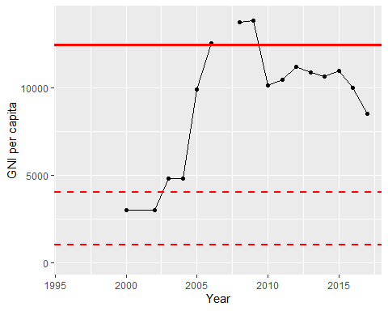

GNI Per Capita Trend